**Predicting Opioid Drug Prescriptions among Prescribing Specialists**

*Jimmy Smart*

1. **Introduction and Data background**

Accidental death by fatal drug overdose is a rising trend in the United States. What can we do to help?

Below is a dataframe that I will be using to dive into the opioid crisis as I wrangle through and provide visuals that pertain to the csv dataframes I have available.

The 1st one, opioid.csv, lists the known opioid drug names and their generic names. The Overdoses.csv contains data provided from the 50 states in regards to their population and opioid related deaths. Finally, the Prescriber-info.csv provides data regarding a specified prescriber. their gender, state, and speciality are provided, as well as the drugs they prescribed to their patients. Opioids and non opioid drugs.

This dataset contains summaries of prescription records for 250 common opioid and non-opioid drugs written by nearly 25,000 unique licensed medical professionals in 2014 in the United States for citizens covered under Class D Medicare as well as some metadata about the doctors themselves. This is only a small subset of data that was sourced from a much larger file: [cms.gov](https://www.cms.gov/).

The data was acquired from Kaggle: [U.S. Opiate Prescriptions/Overdoses](https://www.kaggle.com/apryor6/us-opiate-prescriptions) by Alan “AJ” Pryor, Ph.D. The full dataset contains almost 24 million prescription instances in long format. In the Kaggle form, the data has already been previously cleaned and compiled here in a format with 1 row per prescriber and limited the approximately 1 million total unique prescribers down to 25,000 to keep it manageable.

1. **Key for reading the dataset**

NPI – unique National Provider Identifier number

Gender - (M/F)

State - US State by abbreviation

Credentials - set of initials indicative of medical degree

Specialty - description of type of medicinal practice (109 unique specialties)

Opioid.Prescriber - a boolean label indicating whether or not that individual prescribed opiate drugs more than 10 times in the year

1. **Data wrangling and cleaning**

The original datasets called *opioid.csv*, *overdoses.csv* and *prescriber-info.csv* were loaded in as 3 dataframes into a Jupyter Notebook.Once the data was loaded, the shape of the main dataset (prescriber-info aka prescriber) was confirmed to be 24759 rows by 256 columns. The datasets (opioid and overdoses) were confirmed to be 113 rows × 2 columns and 50 rows × 2 columns respectively.

## Selecting initial variables

An initial glance at the dataset revealed certain variables to be redundant and some containing missing values or contain many unique categories, all of which would provide little information during further analysis or during the modeling process. The following variables were excluded from our dataset with the reasoning provided beside each one:

## Redundant variables from *prescriber* dataset

* Credentials: provided a set of initials indicative of medical degree. They were deemed redundant due to the more important *Specialty* variable
* Within the *State* variable we removed certain US territories such as (PR, AA, GU, AE, ZZ) as we just want to focus on the 50 states. DC was merged into VA

## Finding any null or missing values

The number of missing values for each feature was determined using the prescriber.isnull().sum() method in Python which provided a list of all the variables along with the number of non-null values in each as well as the data type of each variable providing a good overview of the structure of the dataset. *Credentials* variable was the only variable with any null returns. Since we are dropping *Credentials* anyway from our dataset, we can continue on.

## Identifying opioid drug names

Now that we have cleaned up our dataframe a bit we can start looking at the data a bit better. We will start by identifying opioids by comparing drug names found in the *prescriber* dataframe and drug names found in the *opioid* dataframe. Identifying the opioids will help us with our various comparisons between regularly prescribed drugs and opioids.

List of opioids:

MORPHINE.SULFATE.ER

METHADONE.HCL

HYDROCODONE.ACETAMINOPHEN

ACETAMINOPHEN.CODEINE

HYDROMORPHONE.HCL

MORPHINE.SULFATE

TRAMADOL.HCL

FENTANYL

OXYCODONE.HCL

OXYCODONE.ACETAMINOPHEN

OXYCONTIN

## Identifying sum of opioids and non opioids prescribed by specialists

Using the code we just used to identify the opioid drug names, we were able to create a code to find the sum of opioids prescribed by each specialist in our dataset.

prescriber['SumOpi'] = prescriber[opi_presc].sum(axis=1)

As well as the sum total number of prescriptions written by each specialists:

prescriber['TotPresc'] = (prescriber.iloc[:,4:254]).sum(axis=1)

With ‘SumOpi and ‘TotPresc’ we were able to create a 3rd column consisting of the non opioids:

prescriber['NonOpi'] = prescriber['TotPresc'] - prescriber[opi_presc].sum(axis=1)

## Looking at the data with a focus on the States

Wel create a bar graph representing the 50 states and compare total prescriptions vs total opioids prescribed. Fig 1. shows our results. Red represents the total amount of prescriptions while the blue represents the total number of opioids prescribed.

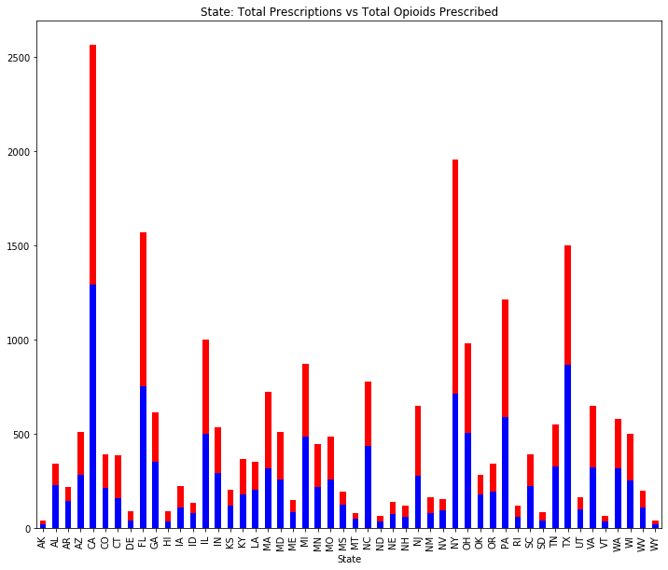

**Fig 1. Total Prescriptions vs Total Opioids Prescribed**

We then grouped the states into 4 geographical categories represented by: North East, Central, South and West. Each region consists of either 12-13 states within their groups. **Fig 2.** shows a pie chart of the breakdown of our results.

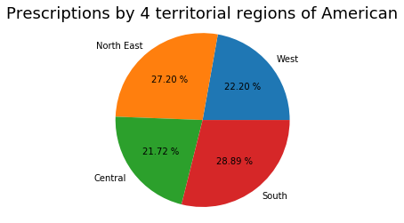

When comparing **Fig 1.** and **Fig 2.** Individually CA and NY lead the way but overall the South carries a bigger percentage of the pie.

## Specialties

Specialties are an important piece to our dataset as they are the main focus of this Capstone in trying to find a trend within the various specialties. For this part of our data modeling we 1st took a look at the value counts. **Fig 3.** Shows the graph we created to show the value counts for the Top 40 various specialties.

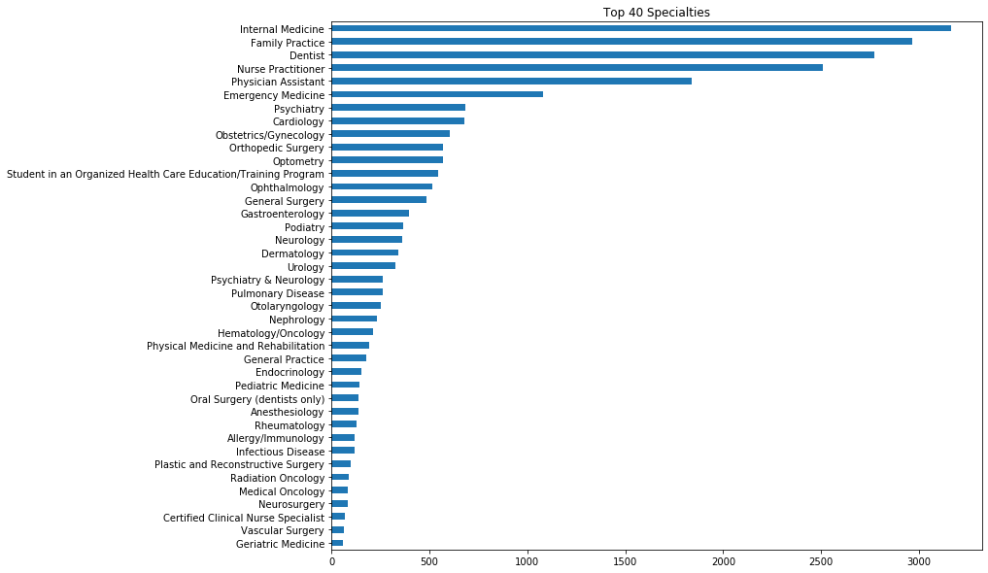

With **Fig 4.** We wanted to show the value counts for the Top 40 specialties who prescribed opioids.

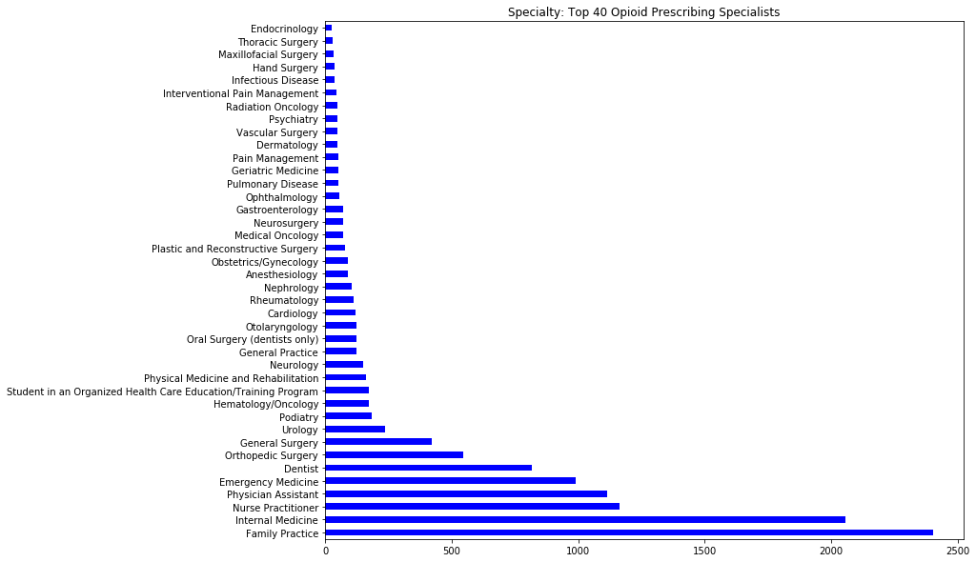

As we can see in **Fig 3.** and **Fig 4.** there is some difference between the respected Top 40s of each graph. Internal Medicine, Nurse Practitioner and Family Practice are at or near the top of each figure.

We created a chart for the top 5 specialists who prescribed opioids and their percentages in reference to the rest of the specialties:

***Percentage of Prescriptions from the top 5 prescribers***

**Value Opi Percent Opi**

**Family Practice** 2402 18.93

**Internal Medicine**  2057 16.21

**Nurse Practitioner** 1165 9.18

**Physician Assistant** 1113 8.77

**Emergency Medicine**  990 7.80

## Gender

First and foremost we wanted to see the percentage differences there were present between Males and Female specialists who didn’t prescribe opioids as well as a pie chart of total differences between Males and Females within our dataset. **Fig 5.** represents a pie chart showing the results.

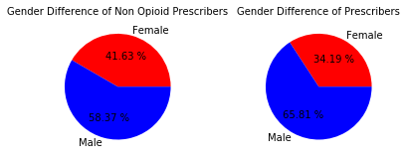

**Fig 5.** Gender Difference of Non Opioid Prescribers and Gender Difference of Prescribers

Overall there were 5025 Females who didn’t prescribe opioids and 7046 Males who also didn’t prescribe opioids.

## Drugs

We took a look at the various drugs available in our dataset. As mentioned previously, we were able to identify the known opioids found within our dataset. We 1st looked at the value counts of these drugs. **Fig 6.** shows our results.

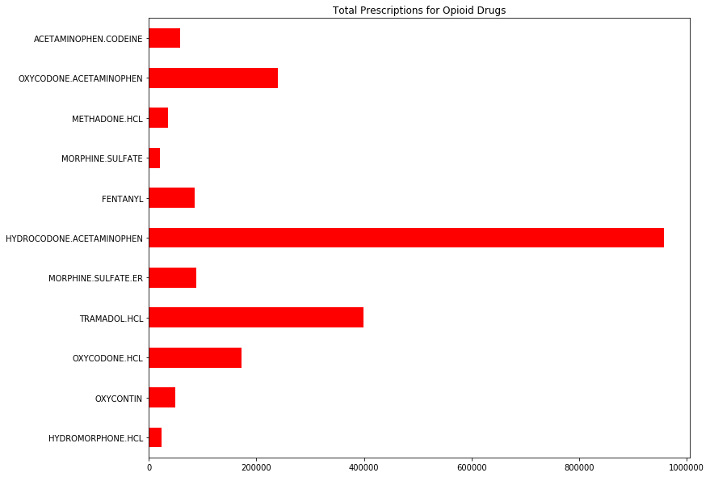

HYDROCODONE.ACETAMINOPHEN 957439

TRAMADOL.HCL 398734

OXYCODONE.ACETAMINOPHEN 240134

OXYCODONE.HCL 172286

MORPHINE.SULFATE.ER 88190

FENTANYL 85344

ACETAMINOPHEN.CODEINE 58477

OXYCONTIN 49727

METHADONE.HCL 35789

HYDROMORPHONE.HCL 23159

MORPHINE.SULFATE 20707

**Fig 7.** shows the top 11 non opioid prescribed drugs.

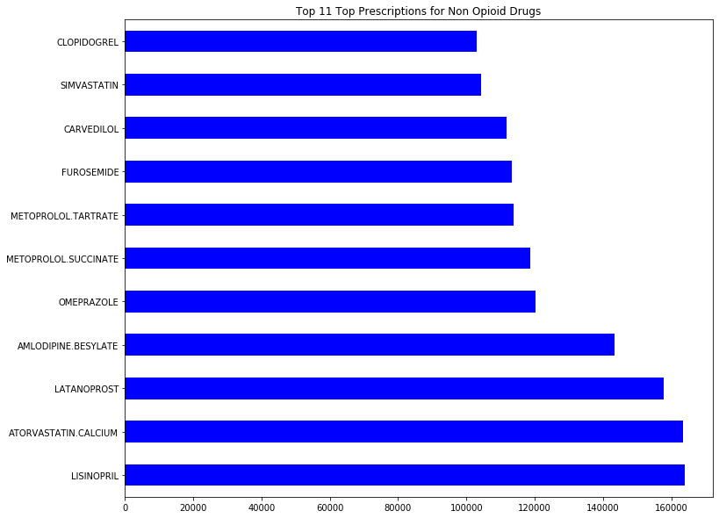

1. **Conclusion**

We just wanted to use this section to get to know our datasets. As mentioned at the beginning, we inherited a fairly clean dataset so we didn’t have to spend too much time in the wrangling and cleaning area. We did want to make the dataset a bit of our own so we created a few new variables as well as took some variables away. As for data visualization, it was helpful to start seeing some of the trends that presented themselves as we started grouping certain variables together. We can see a trend in which specialists seem to be prescribing the most drugs in general, as well as which ones seem to be prescribing the most opioid related drugs. Considering that most opioid drugs are based on pain relief, it’s not surprising to see that certain specialists who deal in medical fields that interact with patients coming to them looking for some sort of pain relief, seem to be the common opioid prescribers. As well as prescribers of non opioid pain relief medications.

We will use our Statistical and Machine Learning sections to better dive into our dataset as we set out to see if we can identify a true correlation between prescriptions and the rise of an opioid epidemic.